Numpy program

Aim
To write a Python program using the NumPy library to create and display 1D and 2D arrays, zeros array, ones array, identity matrix, and range of values.
Algorithm
1. Start the program.
2. Import the NumPy library using import numpy as np.
3. Create and display a 1D array containing elements from 1 to 5.
4. Create and display a 2D array with 2 rows and 3 columns.
5. Create and display a \(3 \times 3\) array filled with zeros.
6. Create and display a \(2 \times 4\) array filled with ones.
7. Create and display a \(3 \times 3\) identity matrix.
8. Generate and display numbers from 0 to 10 with a step size of 2 using np.arange().
9. Stop the program

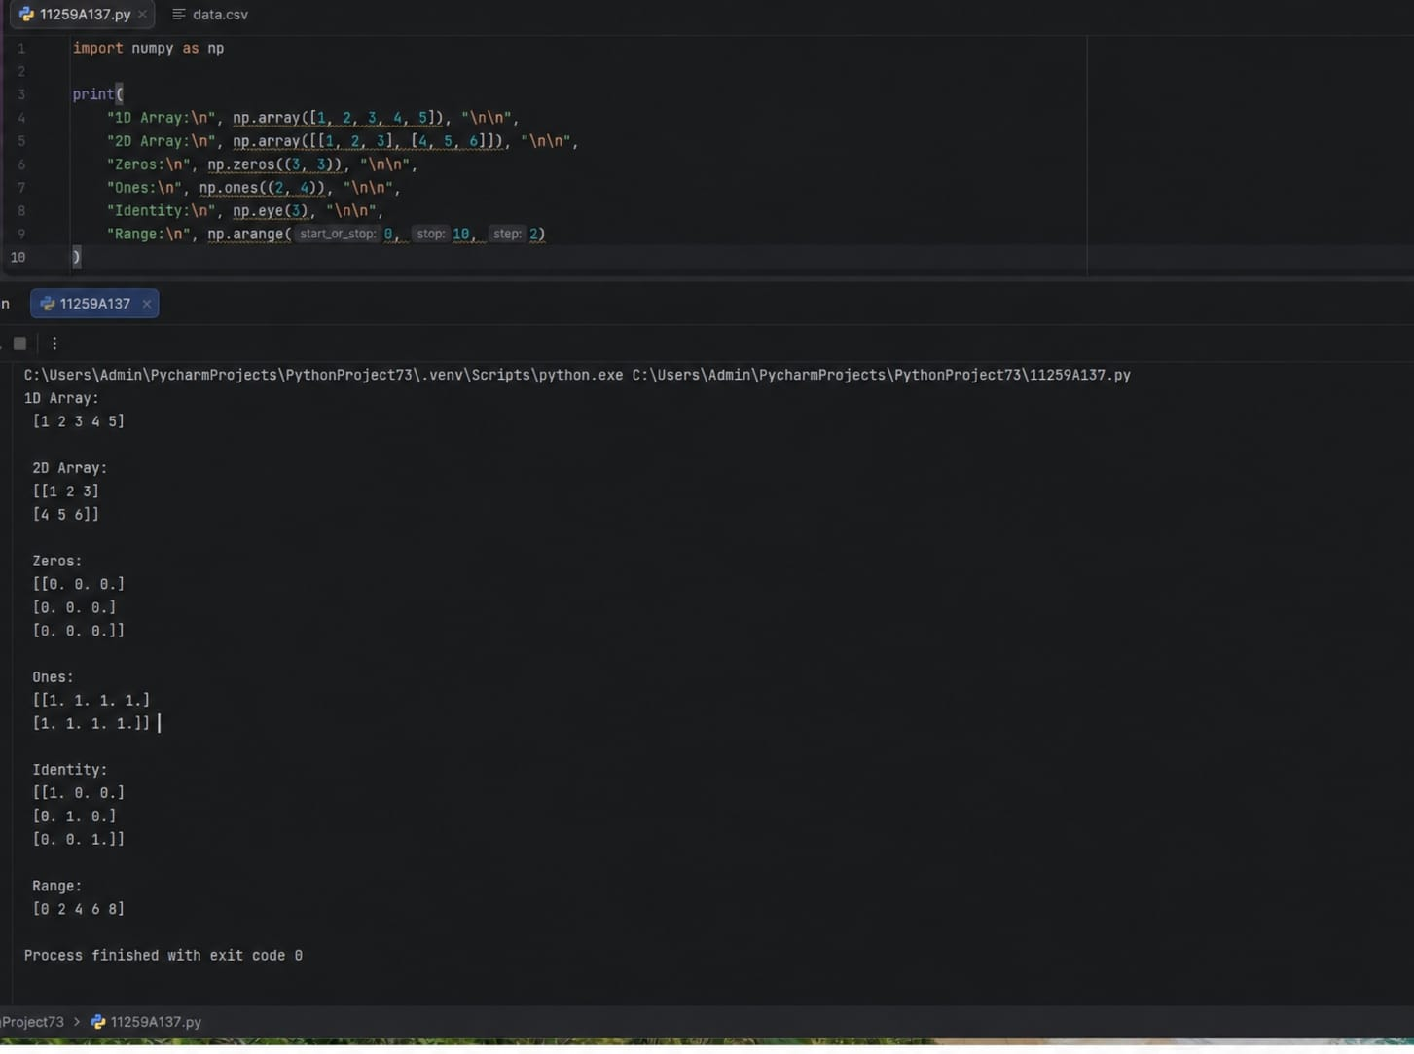
Result
Thus, the Python program using NumPy was executed successfully, and the 1D array, 2D array, zeros array, ones array, identity matrix, and range of values were displayed.

Aim
To write a Python program using NumPy to perform array addition, multiplication, scalar multiplication, square root, mean, and dot product operations.
Algorithm
1. Start the program.
2. Import the NumPy library using import numpy as np.
3. Create two arrays a = [1, 2, 3] and b = [4, 5, 6].
4. Display both arrays.
5. Perform and display array addition using a + b.
6. Perform and display element-wise multiplication using a * b.
7. Perform scalar multiplication using a * 10.
8. Calculate and display the square root of array a using np.sqrt(a).
9. Calculate and display the mean of array a using np.mean(a).
10. Calculate and display the dot product of arrays a and b using np.dot(a, b).
11. Stop the program.
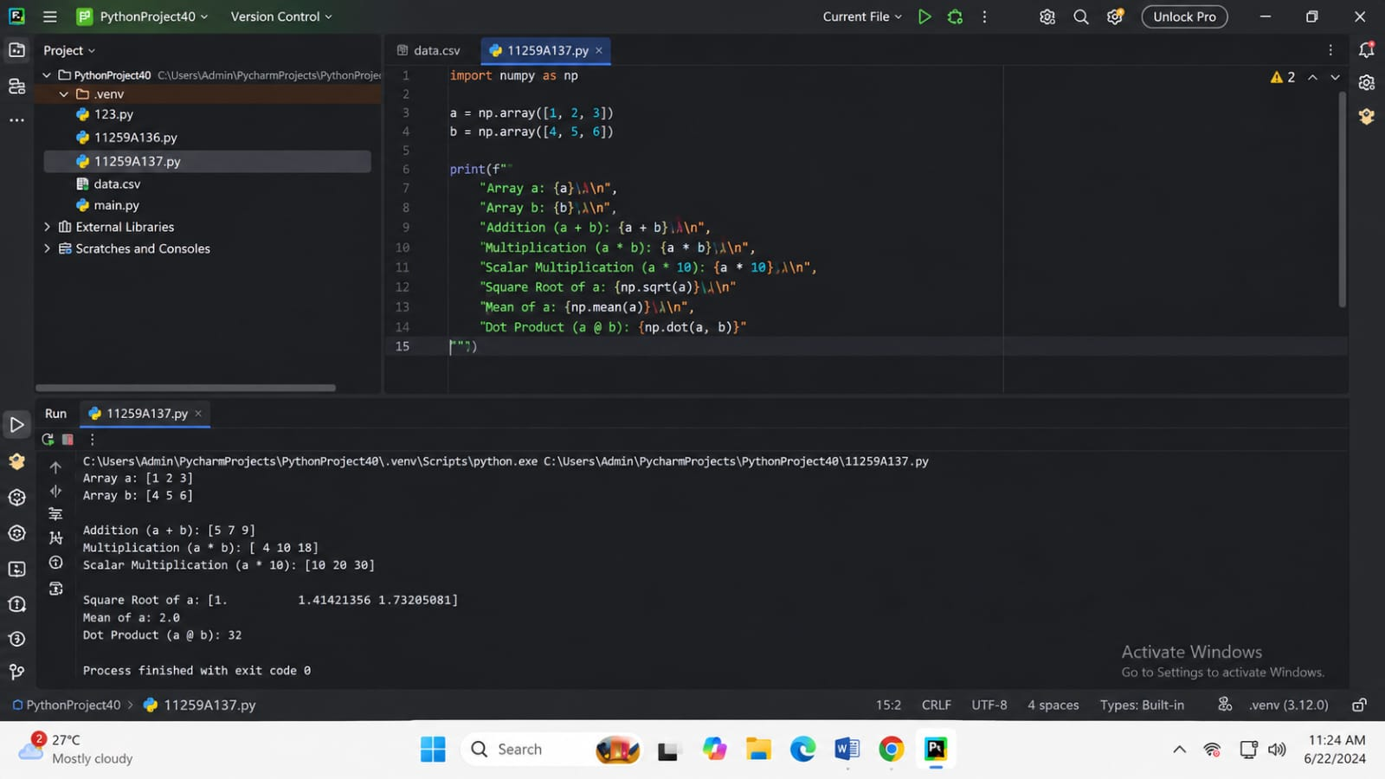
Result
Thus, the Python program using NumPy was executed successfully, and array addition, element-wise multiplication, scalar multiplication, square root, mean, and dot product operations were performed

Aim
To write a Python program using NumPy to perform matrix indexing, row selection, column selection, and sub-matrix slicing.
Algorithm
1. Start the program.
2. Import the NumPy library using import numpy as np.
3. Create a \(3 \times 3\) matrix with the elements 10 to 90.
4. Display the matrix.
5. Access and display the element at index [1, 2].
6. Select and display the first row using matrix[0, :].
7. Select and display the second column using matrix[:, 1].
8. Extract and display the top-left \(2 \times 2\) sub-matrix using matrix[0:2, 0:2].
9. Stop the program.
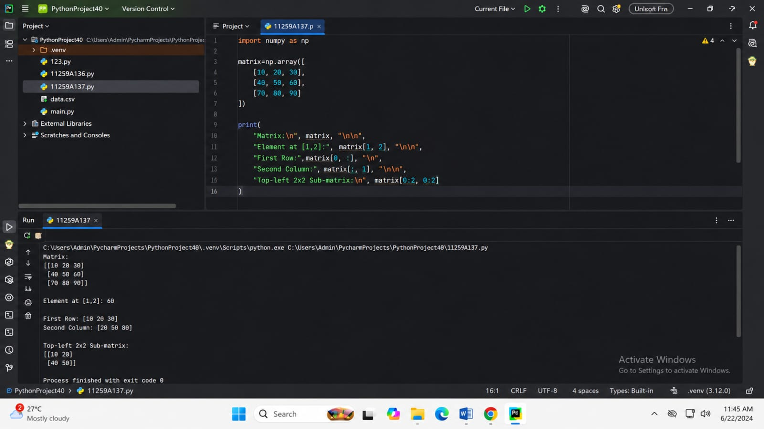
Result
Thus, the Python program using NumPy was executed successfully, and matrix indexing, row selection, column selection, and sub-matrix slicing were performed.

